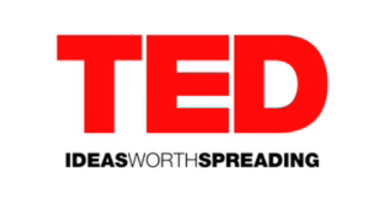
TED is a nonprofit devoted to Ideas Worth Spreading. It started out (in 1984) as a conference bringing together people from three worlds: Technology, Entertainment, Design. On TED.com, we make the best talks and performances from TED and partners available to the world, for free. More than 1400 TED Talks are now available, with more added each week. We believe passionately in the power of ideas to change attitudes, lives and ultimately, the world. So we're building here a clearinghouse that offers free knowledge and inspiration from the world's most inspired thinkers, and also a community of curious souls to engage with ideas and each other. This site, launched April 2007, is an ever-evolving work in progress, and you're an important part of it.

TED.com is an amazing resource. As students in AP Language, this site provides a bounty of great resources at your fingertips. TED Talks will be a consistent piece of the curriculum in this course. Throughout the year you will each choose a TED Talk to build a presentation around.
The process:
- Sign up for a date to present. We will watch one student selected TED Talk a week.
- Visit TED.com regularly. Sign up for email updates. Check out the TED radio hour on NPR. Listen and watch as much as you can.
- Choose your favorite talk for a presentation.
- Watch it carefully and learn from it.
- Develop a short presentation around your talk. You will show the talk to the class and lead your peers on a discussion of the content presented. Develop key questions to examine after you show the talk in class.
- Write a 2 page analysis of the content. Turn in the paper on the day of your presentation.
For tips on writing this paper click here.
- Conduct a beautiful presentation that provokes discussion amongst your peers.

http://www.ted.com/pages/about

